**Lab 01 - 21k-4760**

Task 01:

Command : ls*.txt

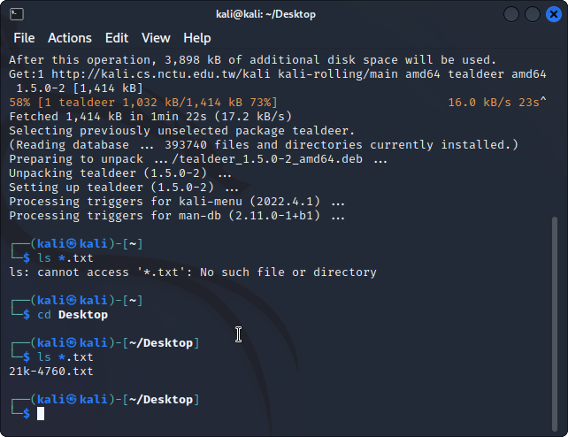

Task 02:

Command : Cat /etc/passwd

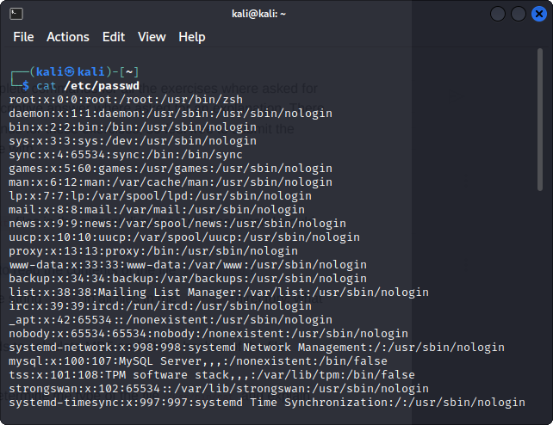

Task 03:

Grep-r ‘error’ /var/log

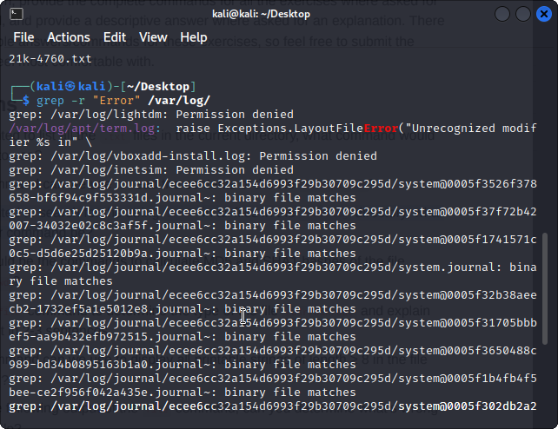

Task 04:

Command : md5sum /etc/passwd

Sha1sum /etc/passwd

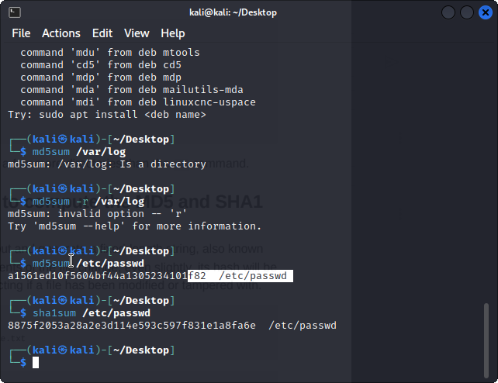

Task 05;

Command : file /usr/bin/cat

Explanation :

This output indicates that the file /usr/bin/cat is an ELF (Executable and Linkable Format) 64-bit executable binary file, built for the x86-64 architecture and compatible with the Linux operating system. The file is dynamically linked, meaning that it depends on external libraries stored in other files, such as /lib64/ld-linux-x86-64.so.2, in order to run.

Task 06:

Command : strings /bin/bash | grep -E '^[ -~]{8,}$'

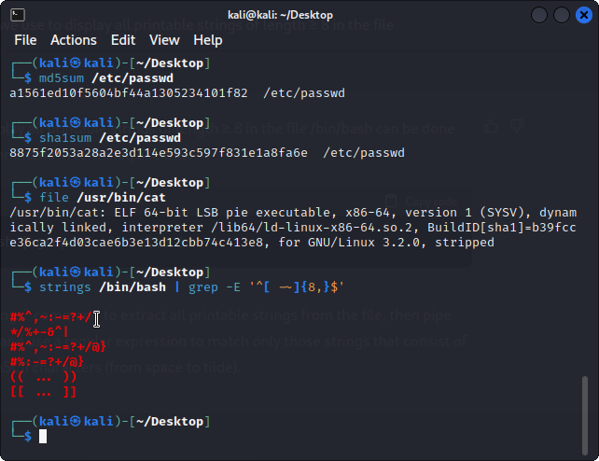

Task 07:

The output you provided shows that the file image.jpg is not actually an image file, but an ELF (Executable and Linkable Format) 64-bit pie executable binary file. The format of the file is not recognizable as an image file, and attempting to open it as an image may result in an error or unexpected behavior.The not stripped part of the output means that the file has not been optimized for size, and still contains debug information and symbols.

Task 08:

Command : find -nmin -30

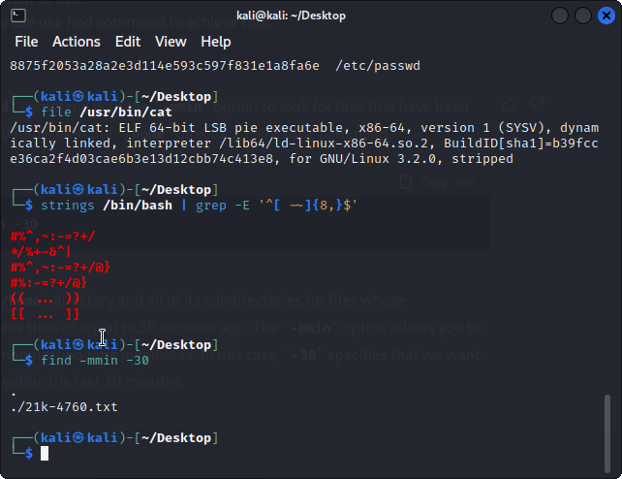

Task 09:

Command : netstat -ant

ss -t (recent and alternative of netstat)

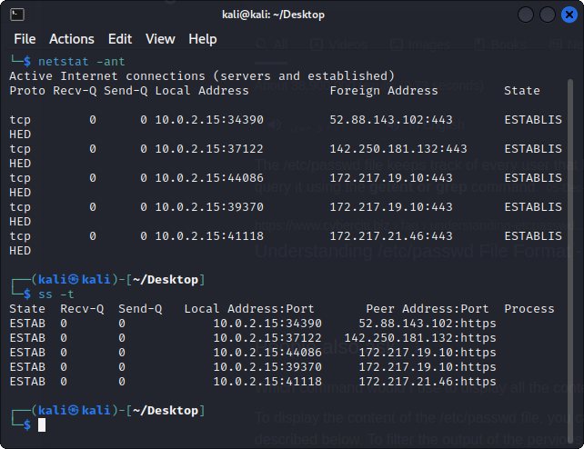

Task 10:

Command : 1st I have used xxd challenge.png | head to view the magic bytes of the .png file. Then I have used hexedit challenge.png command to change its first 08 byte to recover that.

